The Link Between Self-Connection and Youth Risk Behavior

AP Research

Word Count: 4,607

Abstract

With rising levels of anxiety, stress, and depression, adolescents today are facing extremely low levels of happiness and well-being. As a result, they are becoming disconnected from themselves, as well as from their schools, families, and communities. Because of this lack of connection, adolescents are prone to engaging in various risky behaviors that include suicidal ideation, self-harm, drug and alcohol use, excessive gaming, technological overuse, and risky sexual behavior. Current research primarily focuses on the link between external connection (school, family, and community) and risky behaviors. Unfortunately, there is little existing research on the link between self-connection and risky behaviors.

This paper examines the link between self-connection and youth risk behavior. A survey was used to measure the various levels of self-connection amongst students. Then, a regression analysis was used to analyze the data, which yielded statistically significant results. However, the data did not point to any significant relationship between youth risk behavior and self-connection. Further study is warranted to investigate how equipping youth with tools to reconnect themselves internally can have a revolutionary impact on the happiness and well-being of an entire generation.

Introduction
We live in an age where young people are deeply affected by depression and technology overuse. An estimated 350 million young people are affected by depression globally (WHO), and young people check their cellular devices an average of 74 times per day (Westcott). Young people are constantly bombarded by stressors that surround them, including external and internal stressors that vary in severity. External stressors such as high expectations for academic achievement, socio-economic concerns, family disputes, friend group conflicts, and social media pressures, drive young people to feel disconnected from themselves. Internal stressors such as low self-esteem, low well-being, and poor self-perception, have a drastic impact on youth’s self-connection, negatively affecting them at a deeper, root level. When young people are disconnected from themselves, they are more prone to depression, suicide, and mental health issues. As a result, suicide is the second leading cause of death amongst young people in the US (NIMH). The epidemic the world is facing today, characterized by extreme levels of suicide, self-harm, and drug and alcohol abuse, is a direct consequence of young people who have lost their ability to deal with internal and external stressors. In other words, they have lost awareness and control of the thoughts and feelings inside and around them.
In this paper, self-connection means the ability to tune into your inner self and achieve a sense of peace, by becoming aware of your thoughts, feelings, and emotions. In contrast, disconnection means lacking the ability to be at peace with your inner self, consequently, feeling overwhelmed and enveloped by your thoughts, feelings, and actions.
During my lifetime, I have gone on a journey from being disconnected with my inner self to feeling connected at the deepest levels. I was able to rediscover my self-connection by addressing what I believe to be the root cause of the problem at hand. Before that, I had solely been trying to course-correct the surface causes of my feelings of despair. It is safe to say that at one point in my life I was deeply depressed and even suicidal. By addressing the root cause of my disconnection, I was able to rise up from the depths of despair. The surface causes of my depression stemmed from externals stressors, such as socio-economic worries, stress from my friends and family, pressure for succeeding in school and athletics, and a downright lack of confidence. When combatting my depression, I had only looked at these surface causes and had not examined the real problem at hand. The root causes of my suicidal feelings were internal stress and negative self-perception, which led to deep levels of disconnection from myself. In this regard, I lacked a connection to myself, and could never truly be at peace. Because my mentors and I only addressed the surface causes and did not initially focus on correcting the root cause, I sank further into depression and even contemplated suicide. In actuality, very little research has been conducted on the root causes of depression and risky behaviors.
Based on personal experience and extensive background research, I predict that the root cause of the myriad of problems that young people face today stems from a fundamental lack of peace and inner awareness ⎯ essentially a lack of self-connection. Based on this prediction, I hypothesize that an increase in self-connection will result in a decrease in risky behaviors and their harmful associations, including depression. Consequently, a decrease in self-connection, will result in an increase in risky behaviors. In other words, when you feel good about yourself, you are less likely to drink, do drugs, and harm yourself to escape from the bad feelings you are experiencing on the inside.
Although there is little research on the relationship between self-connection and risky behaviors, there is some research on how school and social connection affect risky behaviors. When analyzing the current literature across different fields, it was extremely difficult to find research on self-connection and the positive effects that come with an increased level of self-awareness. However, many studies indicate that students with low school connectedness, but neutral social connectedness have elevated levels of anxiety and depressive symptoms (Bond).
According to the CDC, risky behaviors amongst youth can be defined as risk-taking behaviors that include: dangerous driving, drug use, drinking, excessive gaming, technological overuse and risky sexual behavior (CDC). According to The National Alliance on Mental Illness (NAMI), mental health can be defined as one’s susceptibility to anxiety, depression and suicidal ideation, which encompasses the mental and emotional state of a student’s well-being (NAMI). According to the World Health Organization, well-being can be defined as one’s current state of physical, mental and emotional health, and not merely the absence of disease or infirmity (WHO). For the purposes of this paper, Youth Risk Behavior (YRB) refers to both risky behaviors and mental health issues. In other words, the total well-being of a young person.
Current research suggests a missing link in the field of youth happiness and well-being. Existing research has gone into depth regarding the many intricacies of school and community connection and their respective correlation to YRB. However, there is limited research that suggests how self-connection affects an adolescent’s happiness and well-being. Closing this research gap will lead to greater understanding of the root causes of youth disconnection, not just from their community and school, but from themselves, and subsequent engagement in risky behaviors. This understanding can help address the rise in YRB seen in society in recent years.

Literature Review
For the purposes of this research paper, a young person’s external connection refers to their school, family, and community connection. Additionally, external connection can be further divided into (1) school connection, and (2) social (family and community) connection. School connection can be defined as the degree to which students are aware, engaged, and active within their school environment ⎯ which consists of academic, athletic, and extracurricular activities. Family and community connection can be defined as the quality of a young person’s relationship with their main source of support. In contrast, a young person’s internal connection refers to their mental and emotional well-being, and level of awareness of their body, mind, and spirit.
When examining the current literature in this field, it is clear that increased levels of external connection result in a myriad of positive outcomes. Conversely, it is evident that decreased connection to young people’s family, community, and school leads to increased YRB. In support of these observations, a study in the Journal of Adolescent Behavior of three thousand youth, has proven that, “Having both good school connectedness and good social connectedness is associated with the best outcome” (Bond). With increased levels of external connection, students were less likely to engage in smoking, drinking, and marijuana use, during later years in life (Bond). On the other hand, “Students with low school connectedness but good social connectedness are at elevated risk of anxiety and depressive symptoms” (Bond). This longitudinal study has shown that youth with lower levels of connection to their external environment are more prone to YRB.
Many additional studies examine the link between YRB and social connection. As social connection increases, YRB decreases, and vice versa. A study published in the National Longitudinal Study on Adolescent Health, that measured 12,118 adolescents in grades 7 through 12, assessed eight YRB areas: “Emotional distress; suicidal thoughts and behaviors; violence; use of 3 substances (cigarettes, alcohol, marijuana); and 2 types of sexual behaviors (age of sexual debut and pregnancy history)” (Resnick). In order to identify risk and protective factors at the family, school, and individual levels, these eight areas were grouped into four domains of adolescent health and morbidity: emotional health, violence, substance use, and sexuality (Resnick). The study concluded that a high connection between an adolescent and their family and community, led to a decrease in their engagement in the 6 risky behaviors, (except for the two types of sexual behaviors measured), further emphasizing the inverse relationship between social connection and YRB.
A growing body of research has established that school connection is associated with lower levels of symptoms associated with depression, and better socioemotional health (Markowitz). According to a study by the University of Oklahoma Health Sciences Center, which investigated 17 youth assets across 1,117 students in Oklahoma City high schools, “Adolescents who feel connected to their school and participate in extra activities like art and sports are less likely to drink alcohol, do drugs or have sex” (Muchmore). In support of these findings, another study discovered that, “Adolescents with lower perceptions of school connectedness,” were more likely to engage in various risk behaviors (Govendor). Further supporting the overwhelming evidence that a lack of external connectedness can act as a risk factor for adolescent’s involvement in risky behaviors (Govendor).
The rise of mental health issues is an increasing problem amongst young people today. Adolescents who participated in a 2019 Pew Research survey on YRB reported the following problems in their communities: 70% identified depression and anxiety as a major problem amongst youth, 55% identified bullying as a major problem, 51% identified drug addiction as a major problem, and 45% identified alcohol abuse as a major problem (Pew). Sadly, these adolescents are correct in their judgements. The probability of adolescents suffering from depression increased by 37 percent in the US alone between 2005 and 2014 (John Hopkins). According to reports based on The Center for Disease Control and Prevention (CDC), alcohol, sex, and substance abuse amongst youth has been on the rise since 2013. Furthermore, data from The National Longitudinal Study in 2017, shows that 67% of youth drank alcohol or drove with an inebriated driver (CDC), and 54.1% of drug users began taking drugs as adolescents, under the age of 18. (NIDA). Clearly, there is a major YRB problem in the United States. In order to combat this issue, it is vital to examine the root cause of the problem. Historically low levels of well-being, self-esteem, and self-awareness amongst adolescents, combined with social pressures, technological overuse, and youth disconnection may point to the root causes of the problem.
The current literature primarily points to socio-economic concerns, social media overuse and other external stressors as the cause of why youth are experiencing historically low levels of well-being. Very little research examines what is happening on the inside of a young person at a deeper, more emotional, and even spiritual level. This indicates that there is an explicit research gap in the field encompassing youth self-connection and the negative externalities that come with it.
Again, the data clearly highlights the indirect relationship between external connection and YRB. By taking the research one step further, through focusing on the root cause of the problem at hand, the current problems that youth face can be reduced and perhaps even eliminated. If there is conclusive evidence to prove that a lack of self-connection is the root cause of youth engagement in YRB, institutions can implement effective programs such as movement and mindfulness-based stress reduction initiatives to reconnect youth with themselves.
Research in this field is essential to improving the well-being of an entire generation, as the teenage brain and body are at crucial stages of development with potential for long-term effects. Adolescents are at a stage of life that bridges childhood and adulthood. The teenage brain, characterized by the demand for: (1) increased sensory experience, (2) social connection, and (3) independence, is growing throughout the critical stages of adolescence (Siegel). There have been studies showing the importance of social connection on brain growth. This may point to how self-connection can highly influence the adolescent brain and one’s perspective on life. According to a study published in the Neuroscience Biobehavioral Review, “Interactions between brain maturation and the social environment at this critical developmental stage may augment risk or promote resilience for mental illness and other health outcomes” (Lamblin). This has major ramifications for the field of youth happiness and well-being, showing that youth who have more external connection also have higher well-being than those adolescents who lack external connection. The implications of this research could potentially point to a major breakthrough. If large amounts of qualitative data could be collected, addressing how youth feel at a deeper level about themselves and how they interact with the world at large, a myriad of problems stemming from YRB could be identified and solved.
The existing research is not sufficient enough to encourage a large-scale transformation towards a society that values well-being and self-connection amongst youth. Studies that show the strong effect external connection has on YRB needs to be clearly highlighted. Interesting findings published in the Journal of Research on Adolescence state that, “Fostering school connection may be an important policy lever for the prevention of depressive symptoms among all adolescents, including at-risk youth” (Markowitz). Additionally, this study goes on to address the problem at large, by emphasizing the need for leveraging school connection to provide positive assets for adolescents on a large scale. Time and time again, the literature on youth external connection suggests that increasing measures of external connection between youth and their social environments yields an increase in overall well-being, and therefore an increase in work-productivity, happiness, and health.
Although limited in their size and credibility, there are a few studies that have attempted to examine how internal connection relates to YRB. Thus, a very small body of literature shows how higher levels of self-esteem, defined as a person's feelings of ‘self-worth’, enhance adolescents overall well-being and reduce YRB (Luhtanean). Conversely, “Low self-esteem has been related to risk behaviors and negative developmental outcomes. For instance, young people with low self-esteem are at high risk for attempting suicide” (Connor). On the other hand, a study of 228 adolescents has proven that as an adolescent's self-esteem decreases over time, their alcohol use increases (Griffin). Additionally, “Researchers have yielded tenuous associations between low self-esteem and risk-taking behaviors or socially problematic outcomes like aggression, substance abuse, and poor school achievement” (Connor). This link needs to be examined in more depth, to truly examine the root causes of YRB.
Research has shown that there is a distinction between how boys and girls react to self-esteem issues. A study in the Journal of Abnormal Child Psychology examining a longitudinal relationship between self-esteem and suicidal ideation shows the following: “For boys, suicidal ideation seemed to have stronger roots in childhood, with significant paths from low self-esteem and hopelessness to early thoughts of self-harm and thence to later ideation. For girls, self-esteem had a small but significant direct effect on later suicidal ideation” (McGee). When conducting research, these nuances must be noted and accounted for because the brain’s developmental processes vary based on age and gender.
All of the current research clearly shows that as an adolescent’s internal and external connection decrease, their YRB increases. However, to truly investigate why students are feeling disconnected from themselves it is necessary to test the root causes of the problem at hand ⎯ their emotional, mental, and spiritual state of well-being. This leads to a crucial question to investigate; To what extent are students who lack self-connection more prone to YRB?

Methods
The methodology of this research project is intended to fill in a research gap within the field of youth happiness and wellbeing. A comprehensive survey that assesses the relationship between engagement in YRB and self-connectedness, was employed. For optimal data collection, questions related to self-esteem, self-love, sense of belonging, and overall well-being were asked. This survey was made to assess student’s self-connection, as well as to ask if students ‘don’t have to engage in risky behaviors to feel good about themselves’. Although every student had their own perception of what self-connection was, survey question one implied self-connection to mean, ‘Feeling like a complete puzzle with no missing pieces’.
Survey questions came from two sources, (1) development questions from the 40 assets. The 40 Developmental Assets are, “Positive experiences and qualities that young people need to help them make healthy decisions” (Search Institute). The framework measures youth external connection and socio-emotional health. As proven through extensive research studies, higher measures of these assets correlate to low YRB, as “Youth who have higher levels of developmental assets are much less likely to engage in a wide range of high risk behaviors” (Search Institute). Additionally, (2) personally developed questions were used in the survey. In terms of scoring, subjects used a scale from one to ten, for each of the 13 questions, where one represented ‘strongly disagree’ and ten represented ‘strongly agree’.
In order to reduce risks throughout the research process the following restrictions were put into place. Before surveys were distributed, the proposed questionnaire went through the school ethics board and received approval upon one contingency: removal of the risky behaviors questionnaire in the survey. This is due to the fact that public schools restrict collecting data on risk behaviors, due to the law-binding requirement to follow up on risky student behaviors, including suicide attempts, depressive symptoms, and mental health issues. Because of this contingency, mental health questions are not included in the survey. However, mental health is alluded to by the nature of questions 1, 2, 3, 5, 6, and 7 (FIGURE 7). Additionally, all questions were mandated to be framed positively. Another measure to minimize risk was a school-wide ‘opt-out’ survey. This survey enabled the legal guardians of students to decide whether or not their children would participate in the upcoming surveys for AP Research projects. To minimize the risks of the survey, subjects could ‘opt-out’ of any question aside from grade level and gender.
The identification of survey participants and execution of the survey are as follows. After all survey participants were approved by their legal guardians, an email was sent out detailing the purpose of this research project. This email was sent out to ten teachers of various subjects and grade levels. The email contained the google survey link, which teachers distributed to their students, who then completed the surveys. The survey took approximately three minutes to complete (13 questions, plus two demographic questions, taking an average of 12 seconds per question) and was distributed to the high school students during a 35-minute free block they have on a daily basis. Additionally, survey links were inscribed on the white board of four classrooms. Survey participants were high school students of varying genders, ethnicities, grade-levels, and socioeconomic statuses. Responses were strictly confidential and used for research purposes only. Students were then given the option to provide personal emails for a focus group and interview. However, there was not enough time to collect qualitative data using those methods.
The hypothesis of this research paper is that students who report higher levels of self-connection will report lower levels of YRB, and vice versa. To test the hypothesis, a linear regression was conducted, and the correlations were analyzed. The data from the 75 students were compiled in a Google Spreadsheet, directly from the Google Forms survey. Multiple analyses were made to define the relationship between YRB and self-connection. A regression equation was used to depict the relationship between student’s self-connection and potential YRB. Although the data was not directly related to each student (upon the denial of the YRB questionnaire by the ethic’s board), it showed general trends amongst youth, depicting the relationship between self-connection and YRB on a broader scope.

Data Analysis

The following information represents and characterizes the data that was collected. When collecting data through the Google Forms survey, 110 participants were marked as viewing the survey. However, only 75 of those students engaged in taking the survey. Of the 75 students who took the survey, 44 were female and 30 were male. Additionally, 56% were sophomores, 38.7% were juniors, 2.7% were freshman and 2.6% were seniors (FIGURE 1) 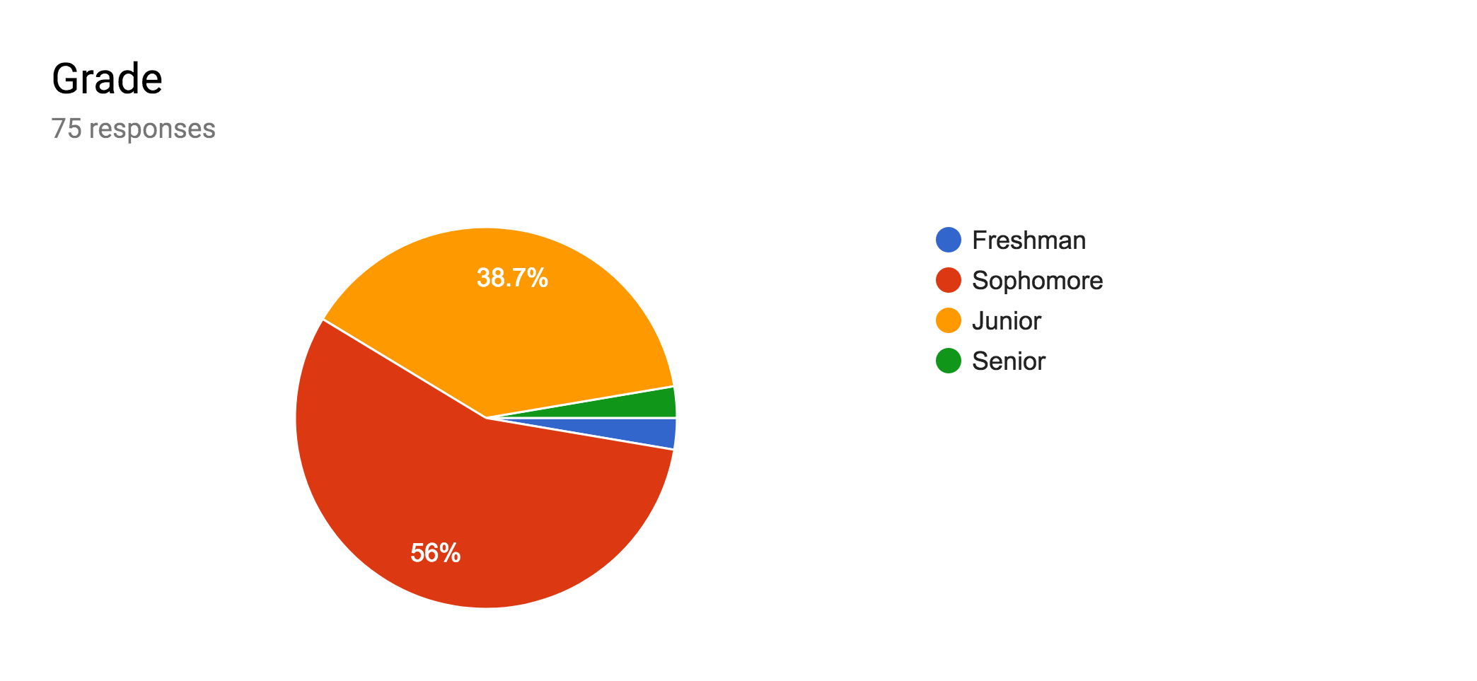

FIGURE 1: Grade Demographics
After in-depth analysis, the most effective form of presenting the data was discovered to be averaging the scores of male and female respondents separately. When asked if, “I feel like a COMPLETE puzzle, with no missing pieces”, 39.2% of respondents indicated a 7 or 8 (FIGURE 2). Additional analysis establishes that the average male reported a 6.47, and the average female reported a 5.59. When survey takers were asked to rank their feelings of self-connection, 60.8% indicated a 7 or above (FIGURE 3). Average male and female participant answers were 6.97 and 6.54 respectively. This data point is interesting because it depicts how students interpreted their feelings of self-connection and quantified their awareness and internal level of connection to themselves. When asked if, “I don’t have to engage in risky behaviors (drugs, alcohol, sex, violence, excessive gaming) to feel good about myself”, 43.2% of respondents reported a ten out of ten (FIGURE 4). The average male reported a 7.1, whereas the average female reported an 8.1. Additionally, students responded strongly to being able to resist peer pressure, as 60.8% of respondents indicated a 9 or 10 (FIGURE 5). Males averaged an 8.67 and females averaged a 7.9. The biggest gap between male and female respondents was responses to question six, “I believe I have control over many things that happen to me”, where the averages were 7.23 and 6.10 respectively, indicating a gap of 1.3 between male and female respondents.
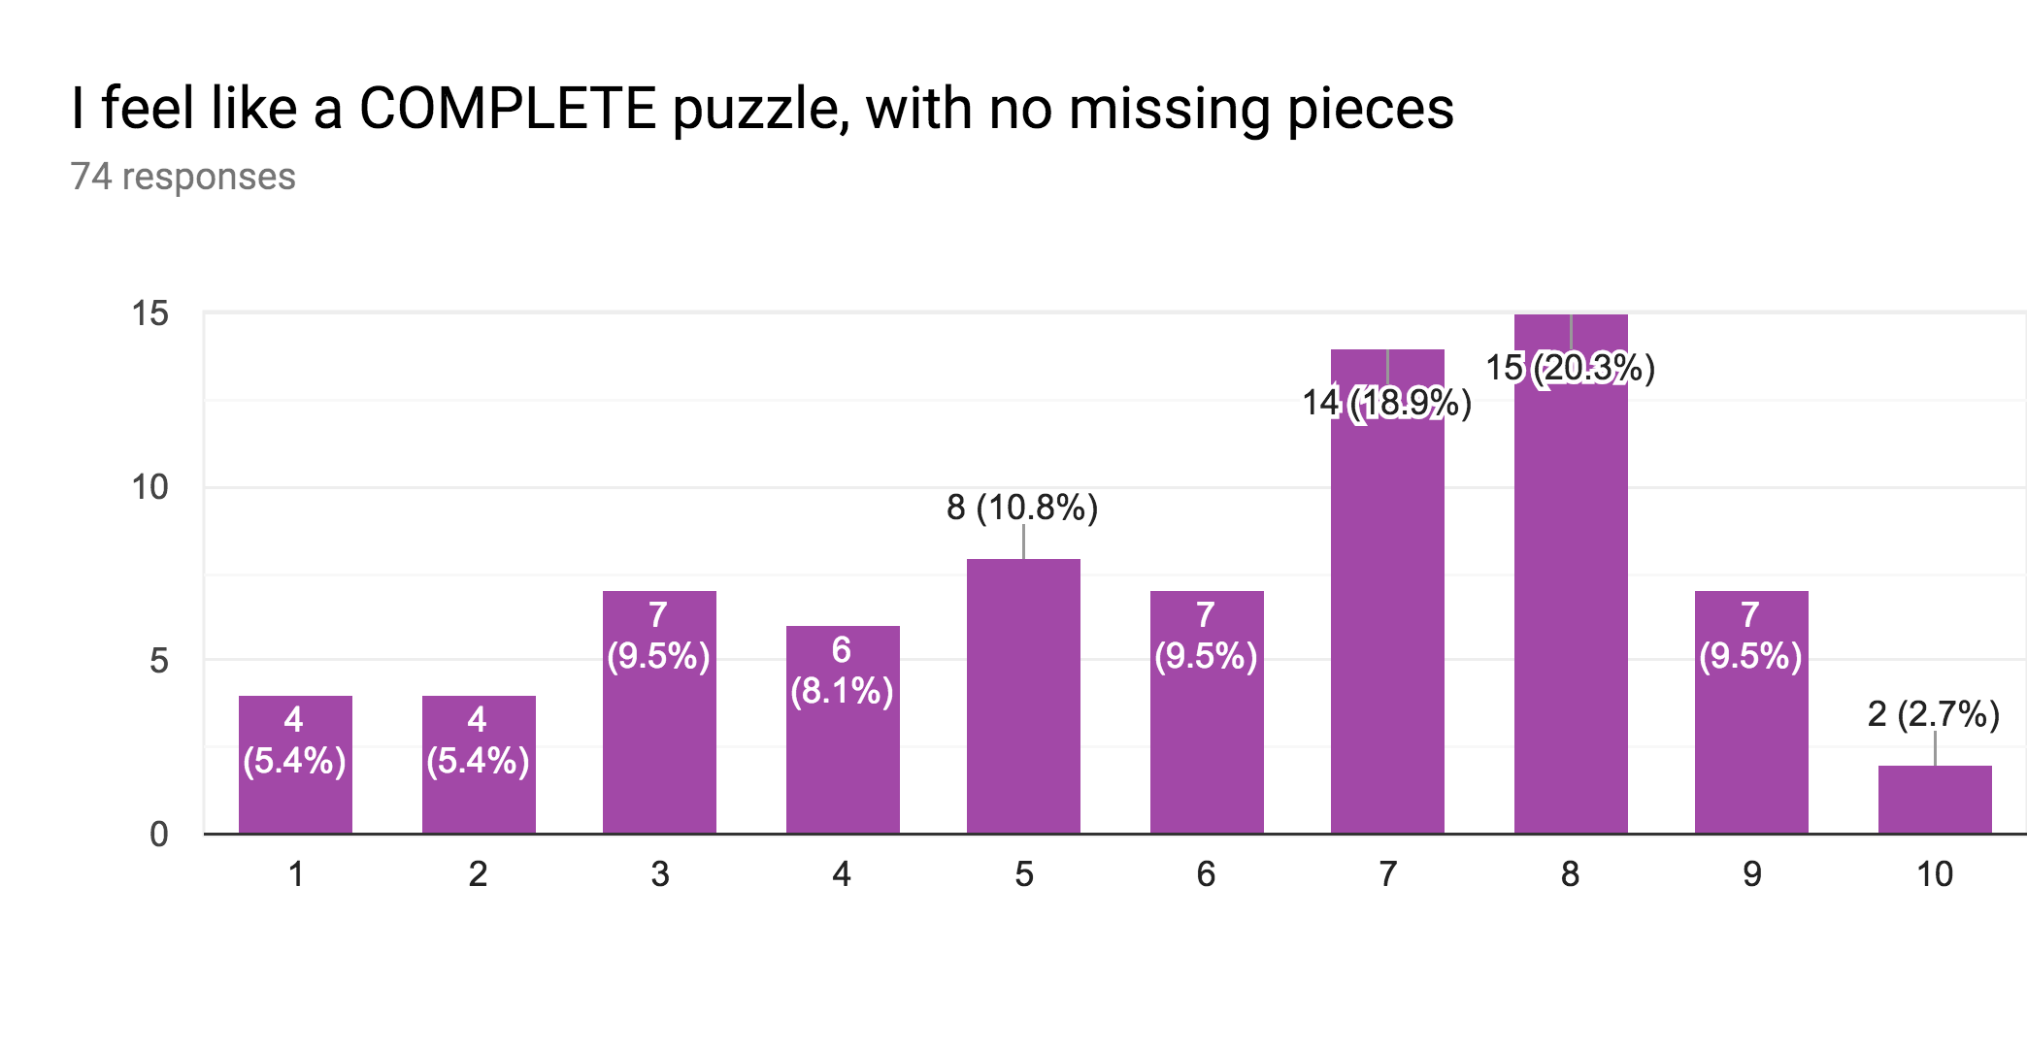

FIGURE 2: Complete Puzzle
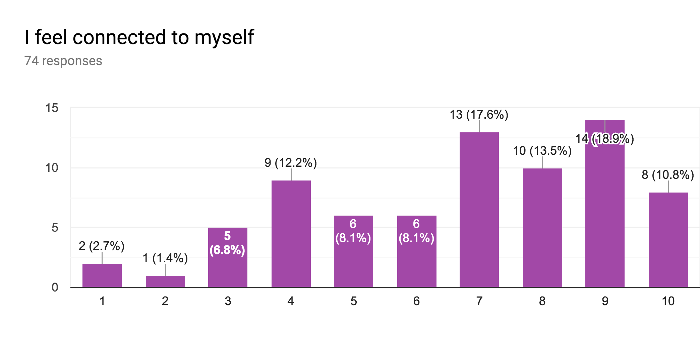

FIGURE 3: Self-Connection
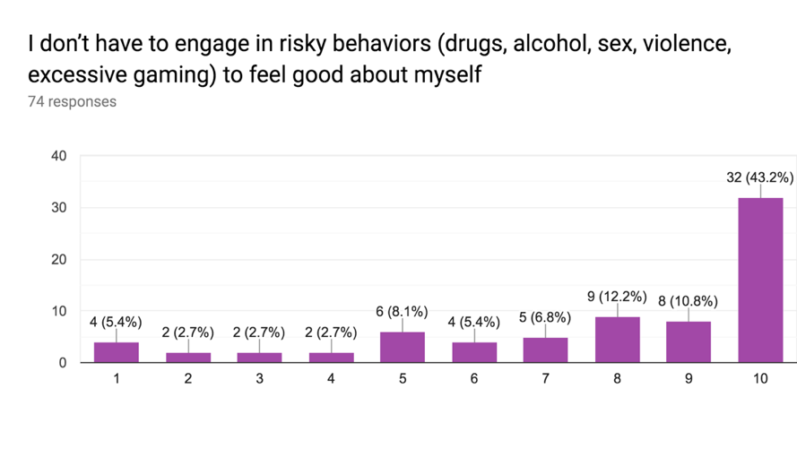

FIGURE 4: Risky Behaviors
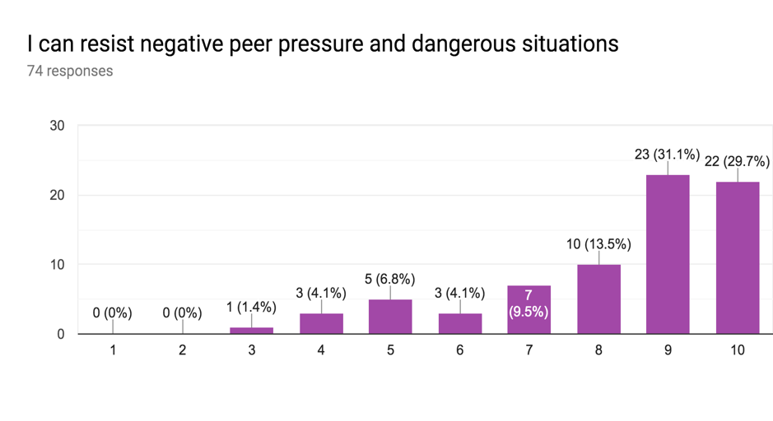

FIGURE 5: Peer Pressure

The data analysis of this project was primarily aimed to identify a relationship between YRB and self-connection. In order to do this, regression analysis was used. Regression analysis is a statistical method that is used to examine the relationship between two variables. After all data was compiled, question four (on YRB) and each of the other questions were compared through regression analysis. The results from the regression analysis, show that this data is conclusive (with a p value less than .05), but the slope of the line of best fit is extremely small, resulting in a miniscule positive relationship.
When looking at the scatter plot graphs, it is clear that there is no definitive relationship between YRB and self-connection. Respondent’s answers were inconsistent, as students who reported high levels of fulfillment, awareness, self-connection, and self-love, did not necessarily report highly on not needing to engage in risky behaviors, to feel good about themselves. When analyzing the relationship between questions four and five, for example, it is evident that the slope of the line of best fit is very small, showing almost no correlation. Therefore, no meaningful relationship can be drawn between self-connection and YRB based on the data.

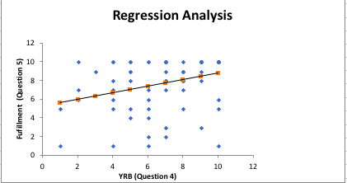

FIGURE 6: Regression
These findings depict that the data is limited in its ability to define an accurate relationship between YRB and self-connection. In other words, there is statistically significant evidence to show that there is no correlation between measures of self-connection and YRB. Therefore, the data has little significance to the study at hand.

Limitations
Although research was conducted with the necessary precautions to minimize risk, there are some faults and uncontrollable variables that could have potentially interfered with the data. Some of the lapses in the data include a limited group of survey takers, unclear terminology, and survey-takers who were unaware of the surveys validity and therefore answered randomly. In this regard, the significance of this data set does not support any strong relationship between participants who selected low measures of YRB (strongly agreeing with not needing to engage in YRB to feel good about themselves), to participants who strongly agreed with feeling connected to themselves and believing their life has a purpose.
Because the results of this research project do not clearly support the data existing in the field of youth happiness and well-being, further study is warranted. Due to evident time restraints, this project was not able to become a longitudinal analysis, as are many of the existing studies in this field. Uncontrollable external variables, such as the class the survey was taken in, the time of day the survey was taken, the level of survey-awareness students received from their teachers, and students who were rushed to take the survey, also could have affected the data set.
Another reason why the data does not show a direct relationship between the two variables is due to the fact that that the ethics board denied the questioning of risk behavior questions. As a result, YRB data was not directly correlated to self-connection. Instead, a broad question was asked that alluded to the engagement of YRB. Thus, the current research gap needs to be further evaluated through extensive study. In the future, with more time for a project of this caliber, a longitudinal study collecting qualitative and quantitative data will be utilized.

Future study
For the reasons described above, this project needs to undergo further investigation in the form of a longitudinal, full-year analysis. Upon the completion of that research, the data could be re-analyzed and the correlation between self-connection and YRB could be re-evaluated. Based on the existing research, one would believe that a longitudinal analysis with focus groups and interviews, could yield data depicting an inverse relationship between YRB and self-connection.
The real-world implications relating to these findings, could truly show the root cause of a myriad of problems adolescents face in our society. A correlation between YRB and self-connection could show that a lack of connection to one’s self is a root cause of adolescent’s engagement in YRB. This would have a plethora of positive effects, as schools and businesses could focus on developing self-connection amongst youth to increase happiness, well-being, and work-place productivity.

Conclusion
The research question of this project is: To what extent are students who lack self-connection more prone to YRB? When reflecting back on this question, it is clear that the study at hand does not have conclusive evidence to directly say that YRB and self-connection have an inverse relationship. However, many other studies have shown that increasing a sense of belonging, awareness and self-esteem amongst youth has a bounty of positive effects ⎯ including the reduction of YRB.
Because of the importance of the relationship between YRB and self-connection, for many generations to come, it is crucial to allocate the necessary resources to study youth self-connection as an aspect of improving well-being, mental health and problems that our youth face today. To combat the rising levels of anxiety, stress, and depression adolescents face today, society must prioritize in-depth study of this field. Helping youth re-discover themselves can lead to a mass transformation and the creation of a world that serves the good of all, by highly valuing the importance of youth happiness and well-being.

Appendix A:

FIGURE 7: Questions survey respondents engaged with.
1)I feel like a COMPLETE puzzle, with no missing pieces.
2) I feel connected to myself.
3) I love myself for who I am.
4) I don’t have to engage in risky behaviors (drugs, alcohol, sex, violence, excessive gaming) to feel good about myself.
5) I feel fulfilled by my activities & pursuits in life.
6) I believe I have control over many things that happen to me.
7) I believe my life has a purpose.
8) I can resist negative peer pressure and dangerous situations.
9) I try to resolve conflict nonviolently.
10) I do what I believe is right, even if my friends make fun of me.
11) I tell the truth, even when it's not easy.
12) I do my best, even when I have a job I don’t like.
13) I stand up for what I believe, even when it’s unpopular to do.

Bibliography

Barry A. Garst and Lance W. Ozier, “Enhancing Youth Outcomes and Organizational Practices Through a Camp-Based Reading Program”, Journal of Experiential Education, 38, 4, (324), (2015).

Bond, Lyndal, et al. "Social and school connectedness in early secondary school as predictors of late teenage substance use, mental health, and academic outcomes." Journal of Adolescent Health 40.4 (2007): 357-e9.

Connor, Jennifer M., et al. "The relation of age, gender, ethnicity, and risk behaviors to self-esteem among students in non-mainstream schools." Adolescence 39.155 (2004).

Daly, Brian, et al. "Promoting school connectedness among urban youth of color: Reducing risk factors while promoting protective factors." The Prevention Researcher 17.3 (2010): 18-20.

Drugabuse.gov. www.drugabuse.gov/publications/drugfacts/nationwide-trends.

Goldin, Nicole. The Global Youth Wellbeing Index. Rowman & Littlefield, 2014.

Govender, Kaymarlin, et al. “Associations between Perceptions of School Connectedness and Adolescent Health Risk Behaviors in South African High School Learners.” Journal of School Health, vol. 83, no. 9, Sept. 2013, pp. 614–622. EBSCOhost, search.ebscohost.com

Griffin, Kenneth W., et al. "Parenting practices as predictors of substance use, delinquency, and aggression among urban minority youth: moderating effects of family structure and gender." Psychology of addictive behaviors 14.2 (2000): 174.

Lamblin, M., et al. "Social connectedness, mental health and the adolescent brain." Neuroscience & Biobehavioral Reviews 80 (2017): 57-68.

Luhtanean, R., & Crocker, J. (1992). “A Collective Self-Esteem Scale: Self-Evaluation of One’s Social Identity”. Personality and Social Psychology Bulletin, 18, 302-318.
http://dx.doi.org/10.1177/0146167292183006

"Most Teens See Anxiety and Depression as a Problem." Pew Research Center,
www.pewsocialtrends.org/2019/02/20/
most-u-s-teens-see-anxiety-and-depression-as-a-major-problem-among-their-peers/.

M, Lamblin. "Social Connectedness, Mental Health and the Adolescent Brain."
National Institutes of Health, Elsevier, Sept. 2017,
www.ncbi.nlm.nih.gov/pubmed/28506925.

Markowitz, Sara, Robert Kaestner, and Michael Grossman. "An investigation of the effects of alcohol consumption and alcohol policies on youth risky sexual behaviors." American Economic Review 95.2 (2005): 263-266.

McGee, R. O. B., and Sheila Williams. "Does low self-esteem predict health compromising behaviors among adolescents?" Journal of adolescence 23.5 (2000): 569-582.

Muchmore, Shannon. Editorial. Tulsa World, 2012, www.tulsaworld.com/news/local/
students-in-activities-less-likely-to-engage-in-risky-behavior/
article_0b66ab0b-513f-597d-8816-18909c1f51eb.html.

“NAMI.”, National Alliance on Mental Illness, www.nami.org/learn-more/mental-health-by-the-numbers.

“NAMI,”, National Alliance on Mental Illness.
www.nami.org/learn-more/fact-sheet-library.

National Institute of Mental Health (NIMH). www.nimh.nih.gov/health/statistics/
suicide.shtml.

Patton, George C., et al. "Promoting social inclusion in schools: a group-randomized trial of effects on student health risk behavior and well-being." American journal of public health 96.9 (2006): 1582-1587.

Racz, Sarah, et al. “Risky Behavior in Affluent Youth: Examining the Co-Occurrence and Consequences of Multiple Problem Behaviors.” Journal of Child & Family Studies, vol. 20, no. 1, Feb. 2011, p. 120. EBSCOhost, doi:10.1007/s10826-010-9385-4.

Resnick, Michael D., et al. "Protecting adolescents from harm: findings from the National Longitudinal Study on Adolescent Health." Jama 278.10 (1997): 823-832.

Siegel, Daniel J. Brainstorm, The Power and Purpose of the Teenage Brain.

Suicide Statistics. AFSP, American Foundation for Suicide Prevention, afsp.org/about-suicide/suicide-statistics/.

"Trends Report." Center for Disease Control and Prevention (CDC).

Underwood, L. G. and Teresi, J. (2002). The Daily Spiritual Experience Scale: Development, theoretical description, reliability, exploratory factor analysis, and preliminary construct validity using health related data. Annals of Behavioral Medicine, 24, 22-33.

Wechsler, Howell. "Youth risk behavior surveillance-United States, 2011." MMWR Surveillance Summary 61 (2012): 1-162.

Westcott, Kevin, and US Telecom. “Global Mobile Consumer Survey: US Edition.” Deloitte United States, 28 Feb. 2019, www2.deloitte.com/us/en/pages/technology-media-and-telecommunications/articles/global-mobile-consumer-survey-us-edition.html.

World Health Organization. www.who.int/features/factfiles/mental_health/en/.

“Youth Suicide Statistics.” Parent Resource Program, 2016, prp.jasonfoundation.com/facts/youth-suicide-statistics/.

